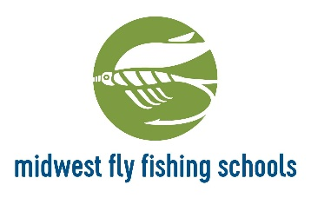

Intermediate Fly Tying Course

Dates: Start Wednesday, March 13th
Then the 3 following Wednesdays, concluding on April 3rd
Time: 7-9 p.m. * If the shop is Closed, please enter through the School Entrance which is to the left of the main store entrance.
Necessary Equipment to bring:
- Functional Vise designed for fly tying (that will hold 2/0- #1 hooks)
- Bobbin (for thread)
- 6/0, 8/0 and 140 Power Thread (color doesn’t matter)
- Hackle Pliers
- Scissors (fine point, designed for fly tying) and Hair/Synthetic Scissors
- Hair Stacker
- Half-hitch tools and/or a whip finisher
- Dubbing Twister/Tool

- Full payment is required to hold your reservation
- Please be aware of our cancellation policies which are posted on our website- by registering for a class, trip or guide, you are agreeing with these terms
- Missed classes can be made up in another session/consult your instructor
- Exception of the 1st class- most important
- All hooks and materials are provided for the classroom tying
- A manual and pattern sheets for each fly tied are provided

Please give us a call if you have any questions! Otherwise, we’ll see you for class.

Mad River Outfitters/Midwest Fly Fishing Schools/Mad River Travel/Ohio Fly Fishing Guides
833 Bethel Rd. Columbus, Ohio 43214
614-451-0363
www.madriveroutfitters.com

